

|  |
| --- |
|  |
|  |
|  |
| **Yotpo**  **Salesforce Commerce Cloud Integration** |
|  |
| ***Yotpo Link Version 21.5.0*** |
|  |
|  |
|  |
|  |
|  |
|  |
|  |
|  |



**Contents**

[**1.**](#_30j0zll) **Summary 4**

[**2.**](#_1fob9te) **Component Overview 5**

[**2.1**](#_3znysh7) **Functional Overview 5**

[**2.2**](#_tyjcwt) **Use Cases 5**

[2.2.1 Use Case # 1: Product Review Widget 5](#_3dy6vkm)

[2.2.2 Use Case # 2: Star Rating Widget 5](#_1t3h5sf)

[2.2.3 Use Case # 3: Automatic Review Requests (post purchase review request emails) 5](#_4d34og8)

[2.2.4 Use Case # 4: Loyalty & Referrals 6](#_2s8eyo1)

[**2.3**](#_17dp8vu) **Limitations, Constraints 7**

[**2.4**](#_3rdcrjn) **Compatibility 7**

[**2.5**](#_26in1rg) **Privacy, Payment 7**

[**3.**](#_35nkun2) **Implementation Guide 8**

[**Prerequisites 8**](#_1ksv4uv)

[**3.1 Setup 8**](#_44sinio)

[**3.2**](#_2jxsxqh) **Configuration 8**

[3.2.1 Cartridge Registration 8](#_z337ya)

[3.2.1.1](#_3j2qqm3) SFRA Version 8

[3.2.1.2](#_1y810tw) Business Manager (Ratings & Reviews Only) 8

[3.2.2 Add Yotpo LINK Cartridge to Code Base: 9](#_4i7ojhp)

[3.2.3 Import Yotpo Site Import (Loyalty Only) 9](#_2xcytpi)

[3.2.4 Import Yotpo Metadata, Services, and Jobs Schedules (Ratings & Reviews + Loyalty) 9](#_1ci93xb)

[**3.3**](#_3whwml4) **URL Mappings (Loyalty Only) 9**

[**3.4**](#_3as4poj) **Referral Promotion, Campaign, and Coupon (Loyalty Only) 10**

[3.4.1 Promotion 10](#_1pxezwc)

[3.4.2 Campaign 10](#_49x2ik5)

[3.4.3 Coupon 10](#_3o7alnk)

[**3.5**](#_23ckvvd) **Job Details (Ratings & Reviews + Loyalty) 10**

[3.5.1 Export Orders (Ratings & Reviews Only) 11](#_ihv636)

[3.5.2 Export Customers and Orders (Loyalty Only) 11](#_32hioqz)

[3.5.3 Export Cartridge Version Information 11](#_1hmsyys)

[**3.6**](#_41mghml) **Services Details 11**

[3.6.1 Authentication Service (Ratings & Reviews Only) 12](#_2grqrue)

[3.6.2 Export Purchase Service (Ratings & Reviews Only) 12](#_vx1227)

[3.6.3 Export Order and Customer Service (Loyalty Only) 12](#_1v1yuxt)

[3.6.4 Export Yotpo Cartridge Configuration 13](#_4f1mdlm)

[**3.7**](#_2u6wntf) **Open Commerce API Settings (Loyalty Only) 13**

[3.7.1 OCAPI Shop Settings 13](#_19c6y18)

[3.7.2 OCAPI Data Settings 15](#_3tbugp1)

[**3.8**](#_28h4qwu) **Template Overrides 16**

[3.8.1 Ratings & Reviews Template Overrides 16](#_nmf14n)

[3.8.2 Loyalty Template Overrides 16](#_37m2jsg)

[3.8.3 Adding Yotpo JavaScript (Ratings & Reviews + Loyalty) 16](#_1mrcu09)

[3.8.4 Adding Product Review Widget (Ratings & Reviews Only) 16](#_46r0co2)

[3.8.5 Adding Product Ratings Widget (Category and PDP) (Ratings & Reviews Only) 17](#_2lwamvv)

[3.8.6 Adding Conversion Tracking Widget (Ratings & Reviews Only) 17](#_111kx3o)

[3.8.7 Adding Logged In Customer and Basket Tracking (Loyalty Only) 17](#_3l18frh)

[3.8.8 Adding Loyalty Widgets (Loyalty Only) 17](#_206ipza)

[3.8.8.1](#_4k668n3) Checkout Redemption Widget 17

[3.8.8.2](#_3ygebqi) Additional Yotpo Loyalty Widgets 18

[**3.9**](#_sqyw64) **External Interfaces 18**

[**3.10**](#_3cqmetx) **Testing 18**

[3.10.1.1](#_1rvwp1q) Product Review Widget 18

[3.10.1.2](#_4bvk7pj) Star Rating Widget 20

[3.10.1.3](#_2r0uhxc) Loyalty Customer Sync 21

[3.10.1.4](#_1664s55) Loyalty Order Sync 22

[3.10.1.5](#_3q5sasy) Loyalty Redemption Widget 23

[**4.**](#_25b2l0r) **Operations, Maintenance 24**

[**4.1**](#_kgcv8k) **Data Storage (Loyalty Only) 24**

[4.1.1 Gift Certificate Custom Attributes 24](#_34g0dwd)

[4.1.2 Order Custom Attributes 24](#_1jlao46)

[4.1.3 OrderPaymentInstrument Custom Attributes 24](#_43ky6rz)

[4.1.4 ProductLineItem Custom Attributes 24](#_2iq8gzs)

[4.1.5 PriceAdjustment Custom Attributes 25](#_xvir7l)

[4.1.6 Profile Custom Attributes 25](#_3hv69ve)

[**4.2**](#_1x0gk37) **Availability 25**

[**4.3**](#_4h042r0) **Support 25**

[**5.**](#_3vac5uf) **User Guide 27**

[**5.1**](#_2afmg28) **Job Schedules and Yotpo Configuration Custom Object 27**

[5.1.1 Job Schedules 27](#_pkwqa1)

[5.1.1.1](#_39kk8xu) Yotpo Order Export (Ratings & Reviews Only) 27

[5.1.1.2](#_1opuj5n) Yotpo Loyalty Customer Export (Loyalty Only) 27

[5.1.1.3](#_48pi1tg) Yotpo Loyalty Order Export (Loyalty Only) 27

[5.1.1.4](#_2nusc19) Yotpo Cartridge Configuration Export 27

[5.1.2 Yotpo Configuration Custom Object Settings 27](#_1302m92)

[5.1.2.1](#_3mzq4wv) Ratings & Reviews Yotpo Configuration Custom Object Settings 27

[5.1.2.2](#_319y80a) Loyalty Yotpo Configuration Custom Object Settings 27

[**5.2**](#_1gf8i83) **Business Manager 28**

[5.2.1 Yotpo Site Preferences 28](#_40ew0vw)

[5.2.2 Set up the yotpoConfiguration Custom Object Settings 30](#_2fk6b3p)

[5.2.3 Set up the yotpoJobsConfiguration (Ratings & Reviews Only) 31](#_upglbi)

[**5.3**](#_1tuee74) **Storefront Functionality 32**

[**6.**](#_4du1wux) **Known Issues 33**

[**7.**](#_2szc72q) **Release History 34**

# Summary

Yotpo’s suite of integrated solutions for user-generated content marketing, loyalty, and referrals helps commerce companies accelerate growth by enabling advocacy and maximizing customer lifetime value. With Yotpo, brands can effectively leverage social proof to increase trust and sales, cultivate loyal customer advocates, and make better business decisions based on customer feedback.

This document provides technical instructions for installing and using Yotpo Salesforce Commerce Link Cartridge, referred to as the Yotpo LINK Cartridge, which enables you to integrate various Yotpo features within a Salesforce Commerce storefront.

Clients using the Yotpo LINK Cartridge can access the following features:

1. Product Review Widget
2. Star Rating Widget
3. Automatic Review Request Emails
4. Loyalty program (earning and redeeming points)
5. Referral program

In order to use the Yotpo LINK Cartridge, customers must be in contract with Yotpo.

# Component Overview

## Functional Overview

Following is the list of features implemented in the Yotpo Link cartridge integration:

* Product Widgets
  + Product Review Widget
  + Star Rating Widget
* Automatic Review Request Emails
  + Order export
* Analytics
  + Purchase conversion tracking
* Loyalty & Referrals

## Use Cases

### Use Case # 1: Product Review Widget



| **Use Case Scenarios** | **Result** |
| --- | --- |
| The merchant needs product reviews displayed on a page or pages on the storefront. The merchant implements the Product Review Widget in a page or pages in the storefront by overriding the appropriate page template(s) as described in section [3.8.4](#_46r0co2). | The user will be able to see the Product Review Widget on those storefront pages. |

### Use Case # 2: Star Rating Widget

| **Use Case Scenarios** | **Result** |
| --- | --- |
| The merchant needs to display star ratings for a specific product on the product page and/or the category listing individual product cards. The merchant implements the Star Rating Widget on the product and/or category landing page template (s) as described in section [3.8.5](#_2lwamvv). | The user will be able to see a Star Rating Widget on those store pages. |

### Use Case # 3: Automatic Review Requests (post purchase review request emails)

| **Use Case Scenarios** | **Result** |
| --- | --- |
| The merchant needs to send an automated post-purchase review request email to customers to collect reviews on their recent purchases. The merchant schedules the job that sends the order data to the Yotpo API. | Customers will receive review request emails according to the Yotpo account configuration. |

### Use Case # 4: Loyalty & Referrals

| **Use Case Scenarios** | **Result** |
| --- | --- |
| The merchant needs to track customer and order data to allow customers to earn and accumulate loyalty points. The merchant configures the Order and Customer data export jobs. | The users accumulate loyalty points and will be able to redeem those points for discounts in subsequent orders. |

## Limitations, Constraints

The Yotpo LINK cartridge includes code and data necessary to enable Yotpo Ratings & Reviews and Yotpo Loyalty on merchant storefronts. Although the cartridge includes the code and configuration for both Yotpo Ratings & Reviews and Yotpo Loyalty, each may be enabled independently. The custom site preferences and custom object settings available with the cartridge installation allow merchants to enable either ratings & reviews, loyalty, or both. Merchants are not required to enable Loyalty in order to use Ratings & Reviews nor are they required to enable Ratings & Reviews in order to use Loyalty.

Use of the Yotpo LINK cartridge by itself does not grant nor enable use of Yotpo product offerings. Yotpo must separately come to a contractual agreement with the client in order for Yotpo to start collecting reviews or rewarding loyalty points on their behalf. Merchants may enable either ratings & reviews, loyalty, or both through their contractual agreement with Yotpo. Please contact Yotpo for details: [sales@yotpo.com](http://sales@yotpo.com).

## Compatibility

The Yotpo LINK cartridge is compatible with StoreFront Reference Architecture (SFRA) version 4.4.1 and Salesforce Commerce Cloud (SFCC) compatibility mode 19.1.

## Privacy, Payment

Masked Order Information and Aggregate Sales Information may be captured as part of purchase tracking implementation on the site.

No customer specific profile data or sensitive information will be stored related to Yotpo LINK cartridge.

The Yotpo LINK cartridge itself is available free of charge. See "[2.3](#_17dp8vu) Limitations, Constraints" section for details regarding potential costs involved with enabling Yotpo to start collecting reviews or rewarding loyalty points on your behalf.

In using the Yotpo LINK cartridge, you agree to be bound by our [Terms of Service](https://www.yotpo.com/terms-of-service/).

# Implementation Guide

## Prerequisites

The merchant must separately come to a contractual agreement with Yotpo to enable either ratings & reviews, loyalty, or both. Ratings and reviews requires a unique “app key” and “client secret key.” Loyalty requires a separate unique “GUID” and “API Key.”

A Yotpo representative must enable an account for the merchant to enable ratings and reviews. As part of this setup, the merchant will be assigned a unique “app key” and “client secret key.” The “app key” and “client secret key” are required to complete the ratings and reviews configuration.

The merchant must register for a Yotpo Loyalty account through the Yotpo Loyalty Admin Registration to enable loyalty. As part of this setup, the merchant will be assigned a unique “GUID” and “API Key.” The “GUID” and “API Key” are required to complete the loyalty configuration.

## 3.1 Setup

The Yotpo LINK integration uses the following cartridges: **int\_yotpo\_sfra** and **bm\_yotpo**.

## Configuration

### Cartridge Registration

Navigate to the following path "Sites **à** Manage Sites **à**  **<Merchant Site>** **à**  Settings"

Add the cartridge name to the Cartridges path as shown in screenshot below:

#### SFRA Version

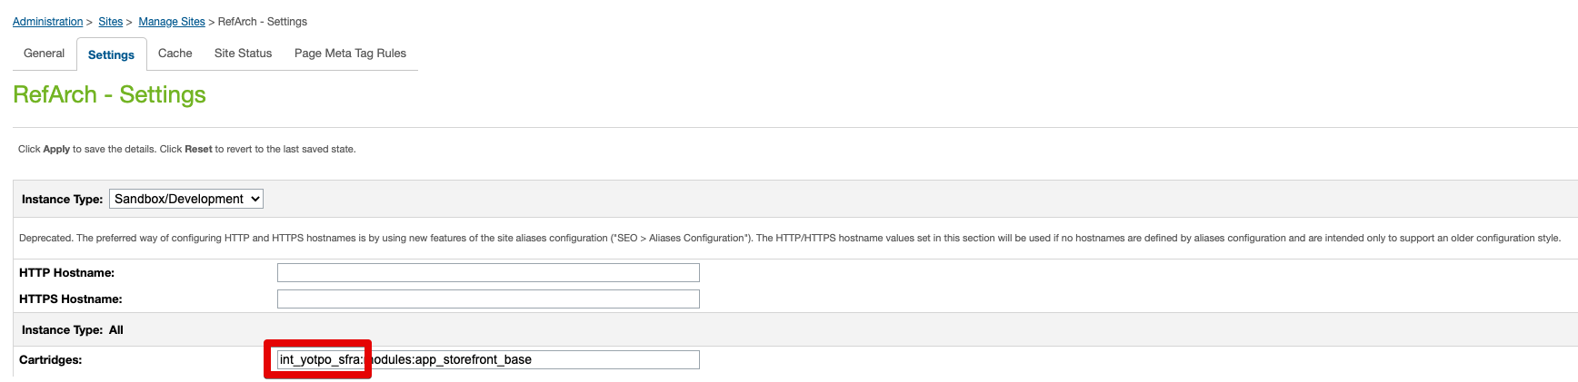

#### Business Manager (Ratings & Reviews Only)

The Yopto LINK cartridge includes a custom interface for managing account configurations in Business Manager.

Navigate to the following path "Sites **à** Manage Sites **à**  Business Manager à Settings

Add the cartridge names to the Cartridges path as shown in screenshot below:

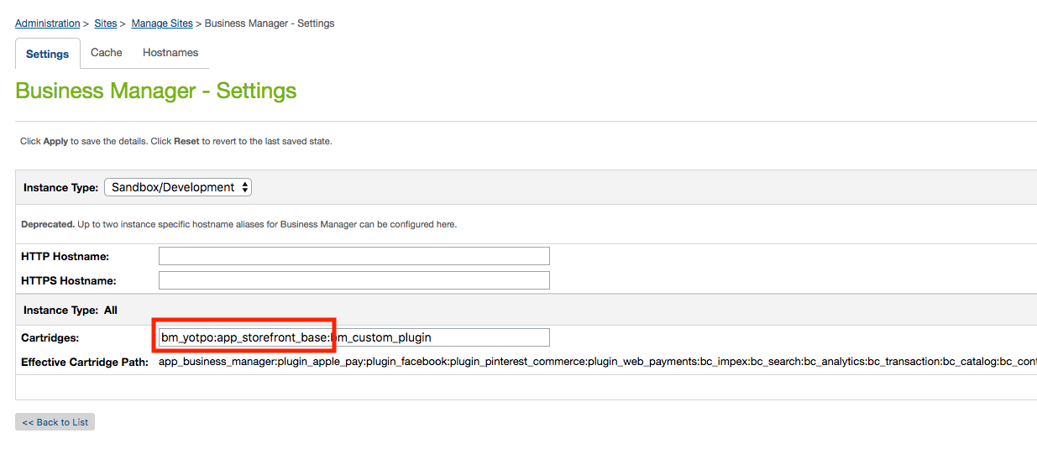

### Add Yotpo LINK Cartridge to Code Base:

The Yotpo LINK Cartridge code must be added to your code base and uploaded to the appropriate Salesforce Commerce Cloud instance prior to site and metadata import.

### Import Yotpo Site Import (Loyalty Only)

The Yotpo cartridge includes a site import file in the cartridge’s Metadata folder. The configurations in this folder are set up to work with a site with a site ID of ‘RefArch.’ You will need to modify the site-specific folder included in the site import to replace references to ‘RefArch’ with the site ID of your site prior to importing.

Navigate to the Metadata **à** SiteImport **à** sites folder in the Yotpo LINK Cartridge. Change the name of the folder “RefArch” to the site ID of your site. Use a compression tool to create a .zip of the SiteImport folder.

* Navigate to Site Development **à** Site Import & Export.
* Select the SitesImport.zip file you just created and click on ‘Import’ and complete the import process through the interface.

### Import Yotpo Metadata, Services, and Jobs Schedules (Ratings & Reviews + Loyalty)

The Yotpo cartridge also includes a metadata.zip import file in the cartridge’s Metadata folder.

* Navigate to Site Development **à** Site Import & Export.
* Select metadata.zip file and click on ‘Import’ and complete the import process through the interface.
* The Jobs, Services, Site Preferences, and Custom Objects will be imported including Yotpo Configurations and Yotpo Jobs Configurations.
* The details on job schedules and services is described in section [3.5](#_23ckvvd) and [3.6](#_41mghml) respectively.
* The details on Yotpo Custom Preferences is described in section [5.2.1](#_40ew0vw). For further details on configuring custom objects see section [5.2.2](#_2fk6b3p) and [5.2.3](#_upglbi).

## URL Mappings (Loyalty Only)

The site import will add the following mappings URLs in Pipeline URLs

Navigate to "Merchant Tools **à** SEO **à** URL Rules à Pipeline URLs"

| Alias | Pipeline |
| --- | --- |
| swell/index/customer | YotpoLoyalty-GetCustomer |
| swell/index/customers | YotpoLoyalty -GetCustomers |
| swell/index/order | YotpoLoyalty -GetOrder |
| swell/index/orders | YotpoLoyalty -GetOrders |
| swell/index/order-count | YotpoLoyalty -GetOrderCountByState |
| swell/index/thirty-day-order-volume | YotpoLoyalty -GetOrderCountByVolume |
| swell/index/create-gift-certificate | YotpoLoyalty -CreateGiftCertificate |
| swell/index/coupon-code | YotpoLoyalty -GetCouponCode |
| swell/index/get-cartridge-information | YotpoLoyalty-GetCartridgeInformation |
| swell/index/add-product-to-cart | YotpoAPI-AddProductToCart |
| swell/index/remove-product-from-cart | YotpoAPI-RemoveProductFromCart |

***Note:*** *These endpoints are consumed by the Yotpo server during the setup of the Commerce Cloud integration through the Yotpo Loyalty Admin. It is important to verify these mappings are set correctly after completing the site import.*

## Referral Promotion, Campaign, and Coupon (Loyalty Only)

The site import will add the promotion, campaign, and coupon configurations that allow Yotpo Loyalty to provide a user with a coupon code when a Loyalty user refers a friend to the Loyalty program for your storefront.

### Promotion

| Name | Description |
| --- | --- |
| Yotpo Loyalty S2F Promotion | Send to Friend Loyalty Discount Promotion. |

### Campaign

| Name | Description |
| --- | --- |
| Yotpo Loyalty S2F Campaign | Send to Friend Loyalty Discount Campaign |

### Coupon

| Name | Description |
| --- | --- |
| yotpoLoyaltyS2FCoupon | Coupon sent via Yotpo Loyalty when a user opts to send to a friend. |

**Note:** The default setup included in the site import gives a user 10% off of their order when a valid yotpoLoayltyS2FCoupon coupon code is applied. The “Yotpo Loyalty S2F Promotion” promotion type, discount, and exclusivity may be modified to provide the desired discount for the Loyalty send to friend experience. The site import will generate 10,000 coupon codes for the “yoptoLoyaltyS2FCoupon.” Additional codes may be added as needed. Promotions, campaigns, and coupons may be accessed through Business Manager by navigating to Merchant Tools -> Online Marketing.

## Job Details (Ratings & Reviews + Loyalty)

Navigate to Administration -> Jobs.

After successfully importing the jobs metadata, the following will be added:

### Export Orders (Ratings & Reviews Only)

| Name | Description |
| --- | --- |
| Yotpo Order Export (Purchase Feed) | This job transfers the purchase feed to Yotpo. |

### Export Customers and Orders (Loyalty Only)

| Name | Description |
| --- | --- |
| Yotpo Loyalty Customer Export | Customer information is sent real-time to Yotpo Loyalty when a customer registers or updates their account via the storefront. The Yotpo LINK Cartridge includes a fall-back mechanism to capture customer information that fails to send real-time in a custom object. This job transfers the fall-back customer information to Yotpo Loyalty. |
| Yotpo Loyalty Order Export | The Yotpo LINK Cartridge captures order information in a custom object when an order is placed. The order information is sent to Yotpo Loyalty real time when the order is successfully confirmed. Order information that fails to send real-time remains stored in a custom object. This job transfers the fall-back order information to Yotpo Loyalty. |

**Note:** A basic configuration for these jobs is included in the metadata import. However, the default site for the jobs is “RefArch.” The correct sites must be configured. This configuration is located under the “Scope” section inside of the “Job Steps” tab.

### Export Cartridge Version Information

| Name | Description |
| --- | --- |
| Yotpo Cartridge Configuration Export | This relays simple Yotpo Cartridge version information to Yotpo periodically. |

### Loyalty Customer Historic Backfill

| Name | Description |
| --- | --- |
| Backfill - Yotpo Loyalty Customer Export | This is meant to be run once and only viable for customers who have historical data on the SFCC platform. The other job is used for the real-time sending of Customer data. |

### Loyalty Order Historic Backfill

| Name | Description |
| --- | --- |
| Backfill - Yotpo Loyalty Order Export | This is meant to be run once and only viable for customers who have historical data on the SFCC platform. The other job is used for the real-time sending of Order data. |

## Services Details

Navigate to Administration **à** Services.

After successfully importing services, following will be added:

| Name | Profile | Credentials |
| --- | --- | --- |
| int\_yotpo\_sfra.https.post.auth.api | int\_yotpo\_sfra.rest.api.profile | int\_yotpo\_sfra.https.post.auth.api.cred |
| int\_yotpo\_sfra.https.post.export.purchase.api | int\_yotpo\_sfra.rest.api.profile | int\_yotpo\_sfra.https.post.export.purchase.api.cred |
| int\_yotpo\_sfra.https.post.loyalty.api | int\_yotpo\_sfra.rest.api.profile | int\_yotpo\_sfra.https.post.loyalty.api.cred |
| int\_yotpo\_sfra.https.post.export.cartridge.config.api | int\_yotpo\_sfra.rest.api.profile | int\_yotpo\_sfra.https.post.export.cartridge.config.api.cred |

### Authentication Service (Ratings & Reviews Only)

URL for authentication token API could be set in *int\_yotpo\_sfra.https.post.auth.api.cred*

|  |
| --- |

**Note:** User and Password not required.

### Export Purchase Service (Ratings & Reviews Only)

URL for Export Post API could be set in *int\_yotpo\_sfra.https.post.export.purchase.api.cred*

|  |
| --- |

**Note:** User and Password not required. Also the **:appKey** will be dynamically replaced in the code when making a service call.

### Export Order and Customer Service (Loyalty Only)

URL for exporting data to Swell could be set in *int\_yotpo\_sfra.https.post.loyalty.api.cred*

|  |
| --- |

**Note:** User and Password not required.

### Export Yotpo Cartridge Configuration

URL for exporting cartridge version information to Yotpo can be set in int\_yotpo\_sfra.https.post.export.cartridge.config.api.cred

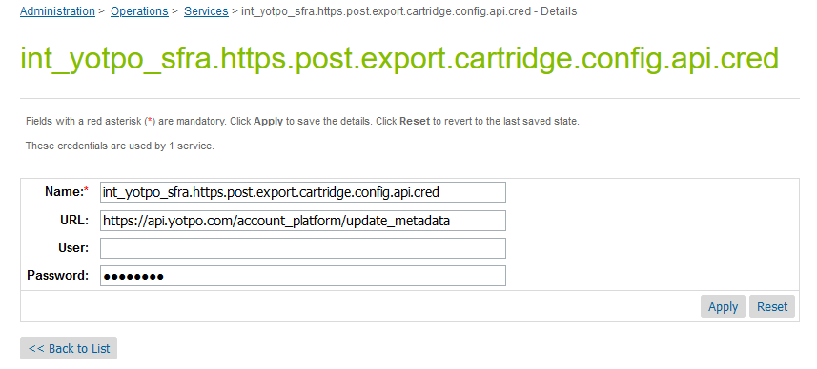

## Open Commerce API Settings (Loyalty Only)

Navigate to Administration -> Site Development -> Open Commerce API Settings.

After successfully importing the metadata, the following Open Commerce API (OCAPI) settings be added:

### OCAPI Shop Settings

| {  "\_v":"20.4",  "clients":  [  {  "client\_id":"aaaaaaaaaaaaaaaaaaaaaaaaaaaaaa",  "allowed\_origins":["https://app.swellrewards.com","https://loyalty.yotpo.com"],  "resources":  [  {  "resource\_id":"/baskets",  "methods":["post"],  "read\_attributes":"(\*\*)",  "write\_attributes":"(\*\*)"  },  {  "resource\_id":"/baskets/\*",  "methods":["get","patch","delete"],  "read\_attributes":"(\*\*)",  "write\_attributes":"(\*\*)"  },  {  "resource\_id":"/baskets/\*/coupons",  "methods":["post"],  "read\_attributes":"(\*\*)",  "write\_attributes":"(\*\*)"  },  {  "resource\_id":"/baskets/\*/customer",  "methods":["put"],  "read\_attributes":"(\*\*)",  "write\_attributes":"(\*\*)"  },  {  "resource\_id":"/baskets/\*/storefront",  "methods":["put"],  "read\_attributes":"(\*\*)",  "write\_attributes":"(\*\*)"  },  {  "resource\_id":"/baskets/\*/items",  "methods":["post"],  "read\_attributes":"(\*\*)",  "write\_attributes":"(\*\*)"  },  {  "resource\_id":"/baskets/\*/items/\*",  "methods":["patch","delete"],  "read\_attributes":"(\*\*)",  "write\_attributes":"(\*\*)"  },  {  "resource\_id":"/baskets/\*/price\_adjustments",  "methods":["post"],  "read\_attributes":"(\*\*)",  "write\_attributes":"(\*\*)"  },  {  "resource\_id":"/baskets/\*/price\_adjustments/\*",  "methods":["delete"],  "read\_attributes":"(\*\*)",  "write\_attributes":"(\*\*)"  },  {  "resource\_id":"/site",  "methods":["get"],  "read\_attributes":"(\*\*)",  "write\_attributes":"(\*\*)"  },  {  "resource\_id":"/customers/\*",  "methods":["get","patch"],  "read\_attributes":"(\*\*)",  "write\_attributes":"(\*\*)"  },  {  "resource\_id":"/baskets/\*/payment\_instruments",  "methods":["post"],  "read\_attributes":"(\*\*)",  "write\_attributes":"(\*\*)"  },  {  "resource\_id":"/baskets/\*/payment\_instruments/\*",  "methods":["patch","delete"],  "read\_attributes":"(\*\*)",  "write\_attributes":"(\*\*)"  },  {  "resource\_id":"/price\_adjustment\_limits",  "methods":["get"],  "read\_attributes":"(\*\*)",  "write\_attributes":"(\*\*)"  }  ]  }  ]  } |
| --- |

### OCAPI Data Settings

| {  "\_v":"20.4",  "clients":  [  {  "client\_id":"aaaaaaaaaaaaaaaaaaaaaaaaaaaaaa",  "allowed\_origins":["https://app.swellrewards.com","https://loyalty.yotpo.com"],  "resources":  [  {  "resource\_id": "/sites/\*/coupons/\*\*",  "methods": ["get", "put", "patch", "delete"],  "read\_attributes": "(\*\*)",  "write\_attributes": "(\*\*)"  },  {  "resource\_id": "/sites/\*/gift\_certificates/\*\*",  "methods": ["get", "put", "patch", "delete"],  "read\_attributes": "(\*\*)",  "write\_attributes": "(\*\*)"  }  ]  }  ]  } |
| --- |

**Note:** A basic configuration for these OCAPI settings is included in the metadata import. However, the default client id for the settings is “aaaaaaaaaaaaaaaaaaaaaaaaaaaaaa.” The correct client ID must be configured. This configuration is located under the “client\_id” section inside of the “Open Commerce API Settings” and must be set to the appropriate client ID for both the “Shop” and “Data” dropdown selections.

## Template Overrides

Several SFRA templates are overridden as a part of the int\_yotpo\_sfra cartridge:

### Ratings & Reviews Template Overrides

*“/int\_yotpo\_sfra/cartridge/templates/default/product/components/descriptionAndDetails.isml”*

*“/int\_yotpo\_sfra/cartridge/templates/default/product/components/productRating.isml”*

*“/int\_yotpo\_sfra/cartridge/templates/default/product/components/ratings.isml”*

*“/int\_yotpo\_sfra/cartridge/templates/default/checkout/confirmation/confirmation.isml”*

### Loyalty Template Overrides

*“/int\_yotpo\_sfra/cartridge/templates/default/account/dashboardProfileCards.isml”*

*“/int\_yotpo\_sfra/cartridge/templates/default/checkout/checkout.isml”*

*“/int\_yotpo\_sfra/cartridge/templates/default/components/footer/pageFooter.isml”*

**Note:** If any of these templates are also overwritten by another cartridge, you will have to merge the changes from that cartridge with the changes made in the Yotpo version of the template. The recommended approach is to create a separate cartridge which contains only the merged templates.

### Adding Yotpo JavaScript (Ratings & Reviews + Loyalty)

For widgets and conversion tracking to work, Yotpo's dynamic JavaScript must be included in the SFRA storefront header file (**i.e.** *htmlHead.isml).* SFRA includes a hook to inject logic into the page header. The int\_yotpo\_sfra cartridge leverages this hook to inject the contents *common/yotpoHeader.isml* into *htmlHead.isml*, which loads Yotpo’s dynamic JavaScript for widgets and conversion tracking based on custom site preference values.

### Adding Product Review Widget (Ratings & Reviews Only)

Product reviews can be added to any product page in your store.

To add product reviews, override the desired template (**e.g.** *descriptionAndDetails.isml*) and include following code snippet:



**See default overridden templates in the cartridge for reference:** *“/int\_yotpo\_sfra/cartridge/templates/default/product/components/descriptionAndDetails.isml”*

### Adding Product Ratings Widget (Category and PDP) (Ratings & Reviews Only)

Product ratings can be added to any product page/tile in your store.

To add product ratings, override the desired template (**e.g.** *productRating.isml* for Product Details Page and *ratings.isml* for Category/Search pages) and include the following code snippet:



**See default overridden templates in the cartridge for reference:**

*“/int\_yotpo\_sfra/cartridge/templates/default/product/components/productRating.isml”*

*“/int\_yotpo\_sfra/cartridge/templates/default/product/components/ratings.isml”*

### Adding Conversion Tracking Widget (Ratings & Reviews Only)

Conversion Tracking should be added to the “**confirmation page**” in your storefront.

To enable conversion tracking, override any order confirmation template (**e.g.** *confirmation.isml*) and include the following code snippet:

**See default overridden templates in the cartridge for reference:** *“/int\_yotpo\_sfra/cartridge/templates/default/checkout/confirmation/confirmation.isml”*

### Adding Logged In Customer, Basket Tracking and Cart Details (Loyalty Only)

For logged in customer, basket tracking and cart details for Yotpo Loyalty, the Loyalty Tracking (*yotpoFooter.isml*) template must be included in your storefront footer.

**See default overridden templates in the cartridge for reference:** *“/int\_yotpo\_sfra/cartridge*/*templates/default/components/footer/pageFooter.isml”*

### Adding Loyalty Widgets (Loyalty Only)

The ability to create custom widgets to include in your storefront is available through the Yotpo Loyalty Admin. To include custom widget injection, the yotpoLoyaltyStaticContentURL custom site preference must be populated and the desired templates must be overridden to include the appropriate widget tag code snippet from Yotpo.

#### Checkout Redemption Widget

The LINK cartridge includes a default overridden checkout template (*checkout.isml)* and affiliated custom site preference (*yotpoLoyaltyCheckoutInstanceID*). The checkout redemption widget must be configured and published via Yotpo Loyalty Admin. The Yotpo Loyalty Admin will provide a widget tag code snippet when you publish the widget through the Admin. Update the *yotpoLoyaltyCheckoutInstanceID* custom site preference with just the ID from the data-yotpo-instance-id from the code snippet (for the following example code snippet, 3145 is the ID you would enter in the yotpoLoyaltyCheckoutInstanceID custom site preference: <div class="yotpo-widget-instance" data-yotpo-instance-id="3145"></div>).

To enable the checkout redemption widget, override the checkout template (**e.g.** *checkout.isml*) and include the following code snippet:



**See default overridden templates in the cartridge for reference:** *“/int\_yotpo\_sfra/cartridge*/*templates/default/checkout/**checkout.isml”*

#### Additional Yotpo Loyalty Widgets

To enable any Yotpo Loyalty widget configured and published via the Yotpo Loyalty Admin, with the exception of the Checkout Redemption Widget, override the desired templates and include the widget tag code snippet from Yotpo.

Example:

## External Interfaces

There are no external interfaces

## Testing

The product reviews, star ratings, or loyalty integration may be tested once the affiliated integration and configuration settings outlined in this integration guide are complete. Test cases presented in this guide assume Yotpo settings and configurations in systems outside of SFCC are set correctly.

#### Product Review Widget

The product review widget will appear on any product detail page, provided the yotpoReviewsWidget template is included correctly in the appropriate template, as described in section [3.8.4](#_46r0co2), and reviews are enabled for the current locale, as described in section [5.2.2](#_2fk6b3p). Test the product review widget on the RefArch site by navigating to a product detail page. The following example illustrates the product review widget on the Summer Bomber Jacket product for the RefArch site.

https://<sfcc-sandbox>/s/RefArch/mens-summer-bomber-jacket/11736753M.html?lang=en\_US

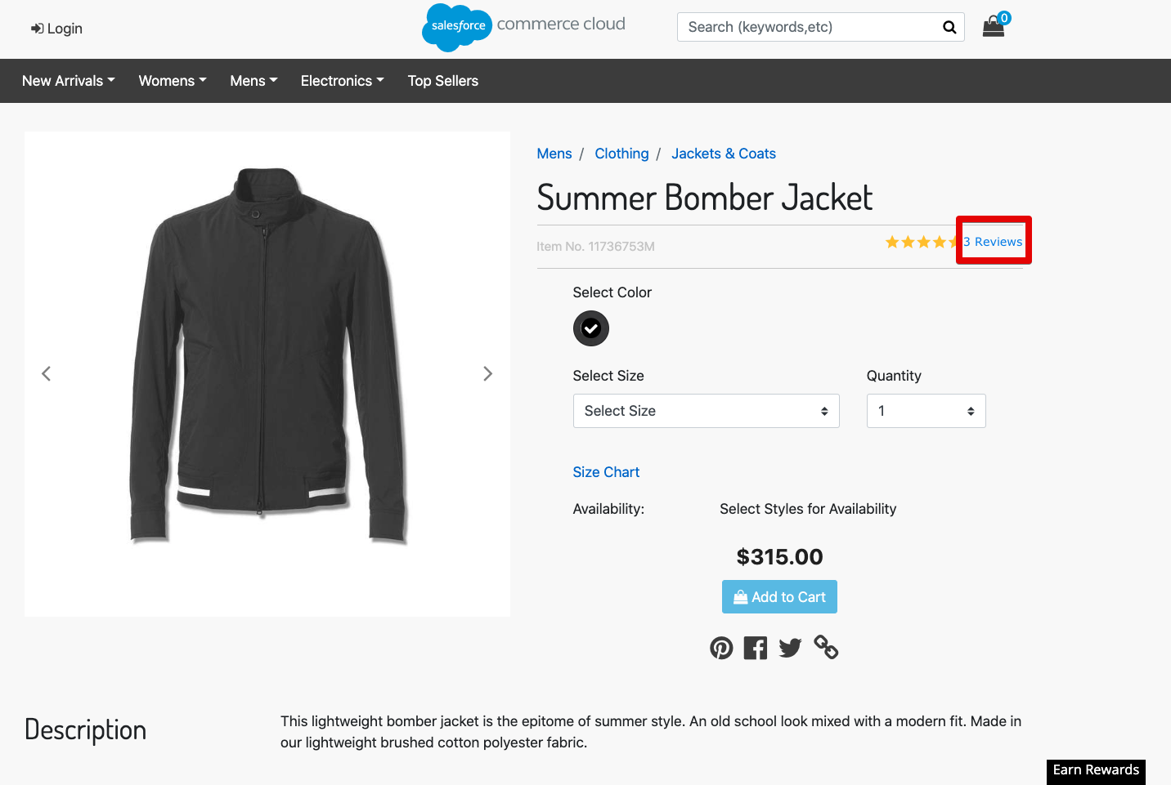

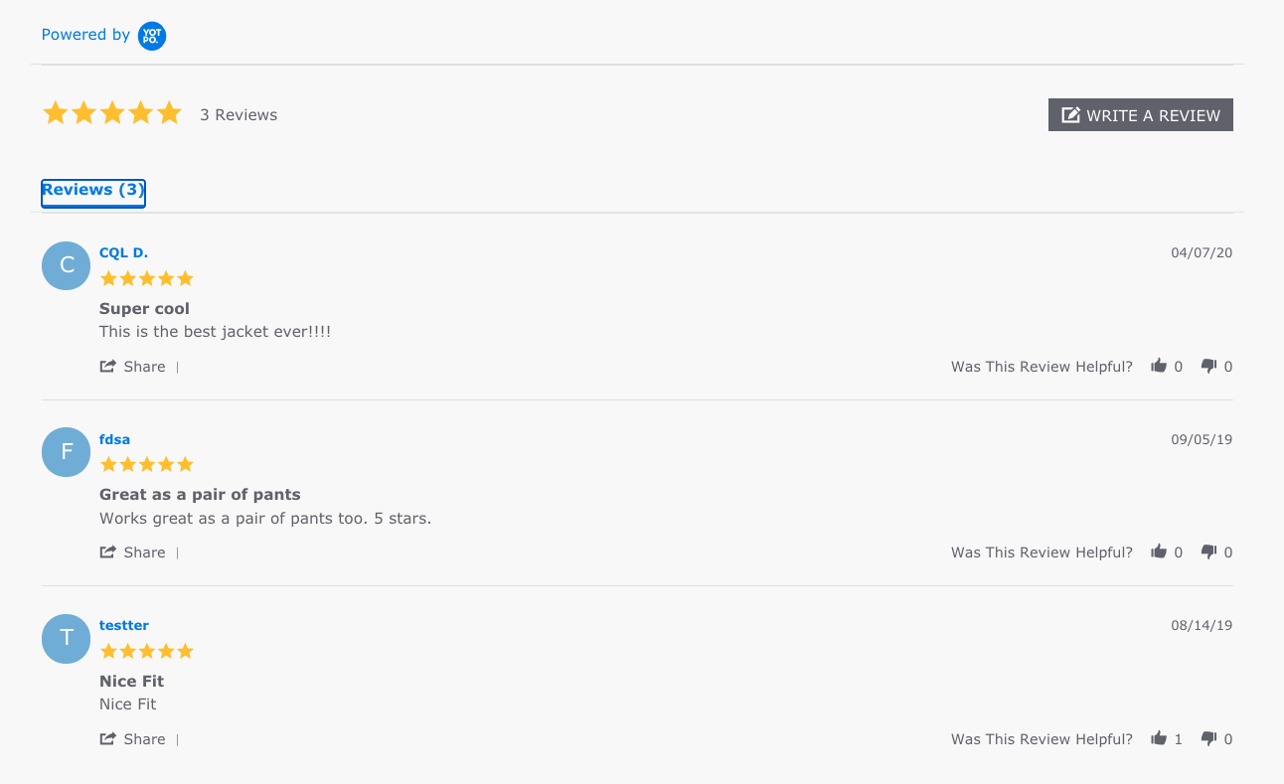

A product that does not have any reviews associated with it yet, such as the Black Flat Front Wool Suit in the following example, will provide a link to allow the user to write a review.

https://<sfcc-sandbox>/s/RefArch/black-flat-front-wool-suit/25686544M.html?lang=en\_US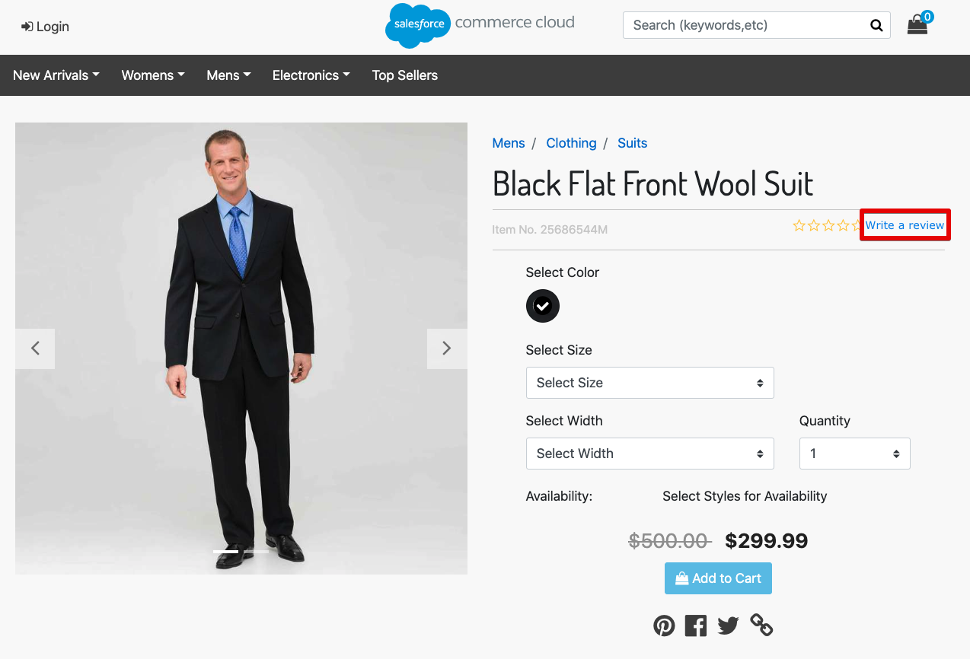

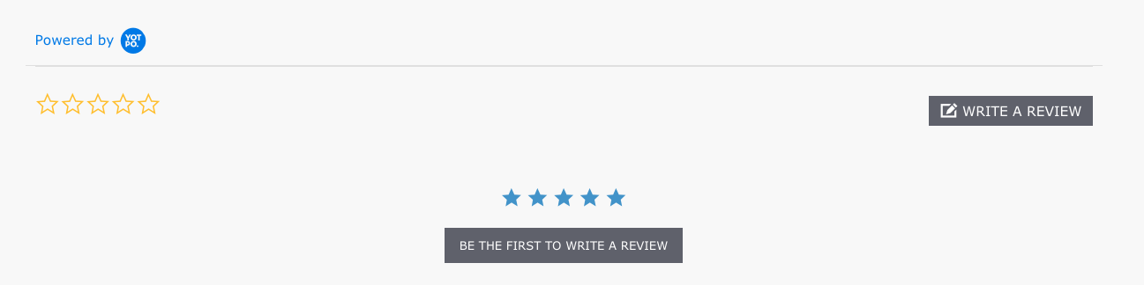

#### Star Rating Widget

The product star rating widget will appear on any category landing page or product detail page, provided the yotpoRatingWidget template is included correctly in the appropriate template, as described in section [3.8.5](#_2lwamvv), ratings are enabled for the current locale, as described in section [5.2.2](#_2fk6b3p), and the product has ratings configured via Yotpo. Test the star rating widget on the RefArch site by navigating to a category on the storefront that contains products with ratings configured. The following example illustrates the star rating widget on the Jackets & Coats category for the RefArch site.

https://<sfcc-sandbox>/s/RefArch/mens/clothing/jackets%20%26%20coats/?lang=en\_US

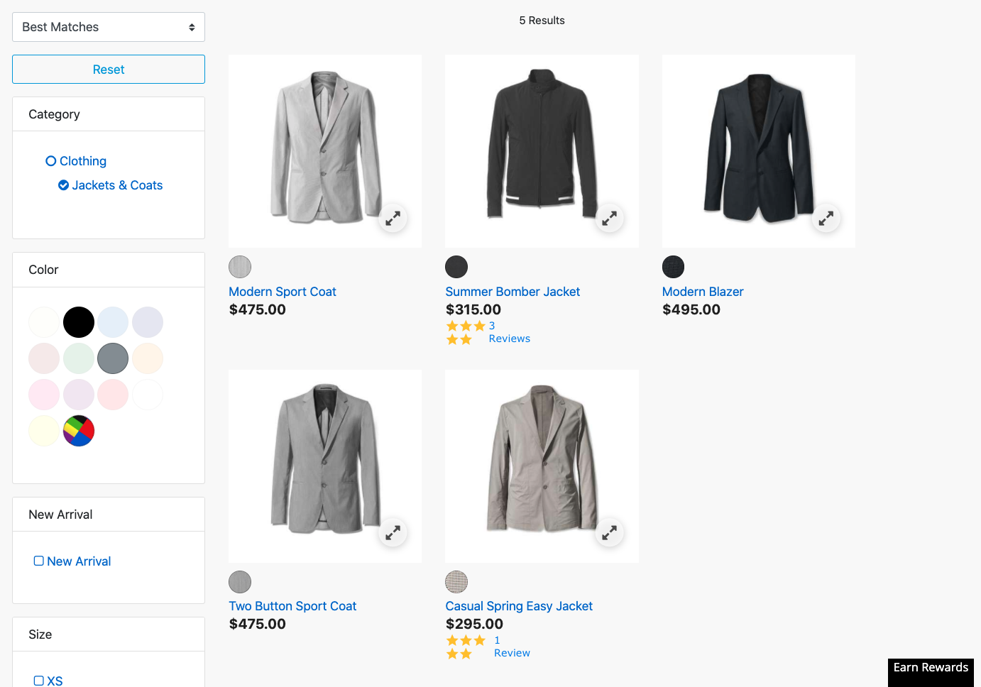

#### Loyalty Customer Sync

Customer information is sent to Yotpo when a customer registers for or edits their account via the storefront, provided the Yotpo Loyalty settings are configured correctly and the integration with SFCC is set up correctly inside the Yotpo Loyalty Admin. If your site has existing customers at the time you set up the Yotpo Loyalty integration, existing customers should automatically be synced with Yotpo Loyalty when you configure the integration with SFCC via the Yotpo Loyalty Admin (integration with SFCC via the Yotpo Loyalty Admin is not part of this cartridge and must be configured in addition to SFCC-specific instructions provided in this integration guide. Please contact Yotpo for additional information and documentation related to the Yotpo Loyalty Admin set up). Test the loyalty customer sync by registering for a new account via the storefront.

https://<sfcc-sandbox> on/demandware.store/Sites-RefArch-Site/en\_US/Login-Show#register

Upon successful registration, you should be able to see the newly registered customer information inside the Yotpo Loyalty Admin.

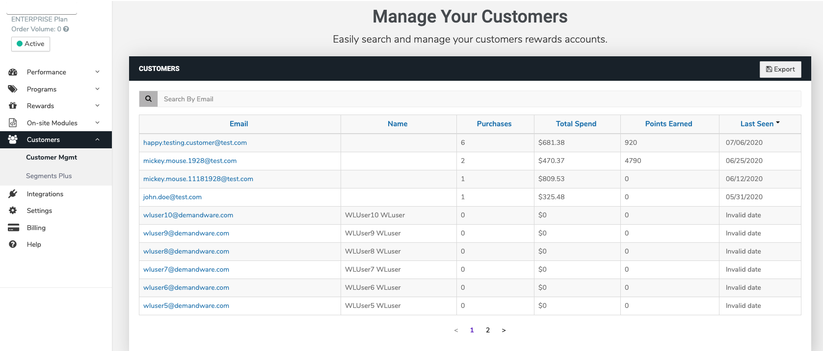

The cartridge includes a fall-back mechanism for capturing customer information for sync with Yotpo Loyalty in the rare event there is communication issue between SFCC and Yotpo Loyalty. A communication issue may be the cause if all integrations and configurations are set properly but you are not seeing a newly registered customer inside the Yotpo Loyalty Admin. In this scenario, a temporary custom object is created to save customer information for attempted send to Yotpo Loyalty via the Yotpo Loyalty Customer Export job described in section [3.5.2](#_32hioqz). Customer information captured under this fall-back scenario may be viewed by navigation to Merchant Tools->Custom Object->yotpoLoyaltyCustomer in Business Manager.

#### Loyalty Order Sync

Order information is sent to Yotpo and order is placed via the storefront, provided the Yotpo Loyalty settings are configured correctly and the integration with SFCC is set up correctly inside the Yotpo Loyalty Admin. Test the loyalty order sync by placing a new order via the storefront.

Upon successful order placement, you should be able to see the total spend updated to include the order amount under the registered customer information inside the Yotpo Loyalty Admin.



The cartridge includes a fall-back mechanism for capturing order information for sync with Yotpo Loyalty in the rare event there is communication issue between SFCC and Yotpo Loyalty. A communication issue may be the cause if all integrations and configurations are set properly but you are not seeing total spend updated with the latest order amount in the Yotpo Loyalty Admin. In this scenario, a temporary custom object is created to save order information for attempted send to Yotpo Loyalty via the Yotpo Loyalty Order Export job described in section [3.5.2](#_32hioqz). Order information captured under this fall-back scenario may be viewed by navigation to Merchant Tools->Custom Object->yotpoLoyaltyOrder in Business Manager.

#### Loyalty Redemption Widget

The Yopto Loyalty redemption widget will appear on the checkout, provided the yotpoRedemptionWidget template is included correctly in the appropriate template, as described in section [3.8.8](#_4k668n3), loyalty is enabled, as described in section [5.2.1](#_40ew0vw), the Yotpo Redemption Widget is set up correctly in the Yotpo Loyalty Admin, the appropriate Yotpo Redemption Widget ID is set on the yotpoLoyaltyCheckoutInstanceID custom site preference, and the registered customer has points available to redeem. Test the redemption widget on the RefArch site by logging into the storefront as a registered user with loyalty points available for redemption, adding a product or products to your cart, and beginning the checkout process.

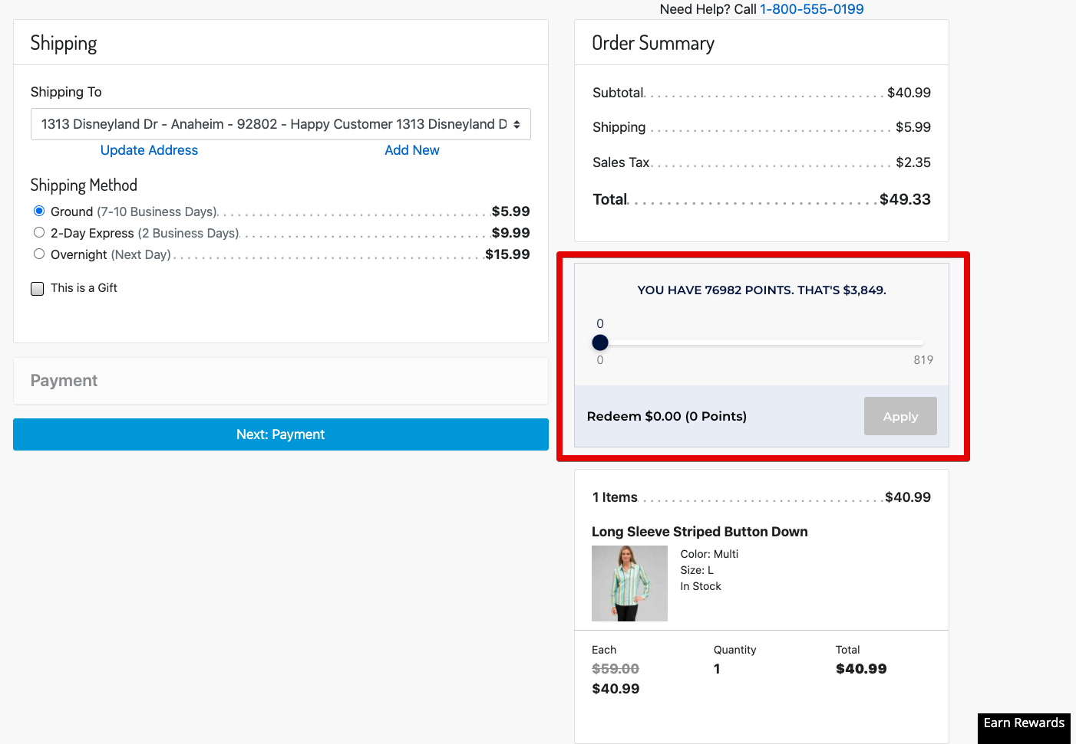

# Operations, Maintenance

## Data Storage (Loyalty Only)

### Gift Certificate Custom Attributes

| **Attribute Definitions** | | |
| --- | --- | --- |
| **ID** | **Name** | **Type** |
| swellPointsUsed | Swell Points Used | Integer |
| swellRedemptionId | Swell Redemption Id | String |

### Order Custom Attributes

| **Attribute Definitions** | | |
| --- | --- | --- |
| **ID** | **Name** | **Type** |
| userAgent | User Agent | String |
| userIPAddress | User IP Address | String |
| **Attribute Grouping** | | |
| **ID** | **Name** | |
| YotpoAttributes | Yotpo Attributes | |

### OrderPaymentInstrument Custom Attributes

| **Attribute Definitions** | | |
| --- | --- | --- |
| **ID** | **Name** | **Type** |
| swellPointsUsed | Swell Points Used | Integer |
| swellRedemptionId | Swell Redemption Id | String |

### ProductLineItem Custom Attributes

| **Attribute Definitions** | | |
| --- | --- | --- |
| **ID** | **Name** | **Type** |
| swellPointsUsed | Swell Points Used | Integer |
| swellRedemptionId | Swell Redemption Id | String |

### PriceAdjustment Custom Attributes

| **Attribute Definitions** | | |
| --- | --- | --- |
| **ID** | **Name** | **Type** |
| swellPointsUsed | Swell Points Used | Integer |
| swellRedemptionId | Swell Redemption Id | String |

### Profile Custom Attributes

| **Attribute Definitions** | | |
| --- | --- | --- |
| **ID** | **Name** | **Type** |
| isLoyaltyProgramInitialized | IsLoyaltyProgramInitialized | Boolean |
| yotpoLoyaltyTier | Yotpo Loyalty Tier | String |
| **Attribute Grouping** | | |
| **ID** | **Name** | |
| Loyalty | Loyalty | |

## Availability

Yotpo services are based on a high-availability infrastructure and have 99.9% uptime. If Yotpo endpoints go down and your pages are unable to get reviews from our servers, the Yotpo reviews and Star Rating will simply not show, it won’t degrade or break your page in any way.

## Support

Contact [Yotpo Support](https://my.yotpo.com/contact_support) regarding this LINK cartridge.

# User Guide

## Job Schedules and Yotpo Configuration Custom Object

### Job Schedules

#### Yotpo Order Export (Ratings & Reviews Only)

The Yotpo Export Orders job should be scheduled to run at least once daily. The Yotpo Export Orders job is required to enable automatic send of post purchase review request emails.

#### Yotpo Loyalty Customer Export (Loyalty Only)

The Yotpo Loyalty Customer job should be scheduled to run at least once daily. The Yotpo Loyalty Customer Export job attempts to send any customer information that failed to send real-time to Yotpo Loyalty, as described in section [3.5.2](#_32hioqz). The job will attempt to resend customer information every time it is run until the customer information is sent successfully or the custom object expires (default expiration of the custom object is 30 days).

#### Yotpo Loyalty Order Export (Loyalty Only)

The Yotpo Loyalty Order job should be scheduled to run at least once daily. The Yotpo Loyalty Order Export job attempts to send any order information that failed to send real-time to Yotpo Loyalty, as described in section [3.5.2](#_32hioqz). The job will attempt to resend order information every time it is run until the order information is sent successfully or the custom object expires (default expiration of the custom object is 30 days).

#### Yotpo Cartridge Configuration Export

The Yotpo Cartridge Configuration Export should be scheduled to run at least once daily. The jobs send simple cartridge version information to Yotpo to support ongoing development.

### Yotpo Configuration Custom Object Settings

#### Ratings & Reviews Yotpo Configuration Custom Object Settings

Verify that **enablePurchaseFeed, enableReviews** and **enableBottomLine** are enabled appropriately in

“Merchant Tools **à** Custom Objects **à** Custom Objects Editor **à** Yotpo Configuration for a specific locale to make ratings, reviews or conversion tracking function.

#### Loyalty Yotpo Configuration Custom Object Settings

The default Yotpo Loyalty API Key and Yotpo Loyalty GUID values for your site should be set in the custom Yotpo Loyalty API Key and Yotpo Loyalty GUID site preferences. Reference section [5.2.1](#_40ew0vw) for more details on the custom site preferences. The Yotpo Configuration custom object also contains attributes (yotpoLoyaltyAPIKey and yotpoLoyaltyGUID) to specify the Yotpo Loyalty API Key and Yotpo Loyalty GUID. However, these custom object values are only used to override the default values set in the custom site preferences and should only be set in the Yotpo Configuration Custom Object settings if the Yotpo Loyalty API Key and Yotpo Loyalty GUID values differ per locale within your site. If your site only has one locale or all of the locales within your site use the same Yotpo Loyalty Admin account, the Yotpo Loyalty API Key and Yotpo Loyalty GUID attributes on the Yotpo Configuration Custom Object should be left blank.

#### Yotpo Jobs Configuration Custom Object Settings

The Yotpo Jobs Configuration object is used as part of the Yotpo Loyalty historic customers and orders backfill. the loyalty\_XXX\_LastId serves as a pointer to that last object sent to Yotpo. As the job is running, that pointer is moved forward until it walks all the objects (either orders or customer). Once it's done walking, it sets the loyalty\_XXX\_ExportComplete boolean to true.   
To begin exports, merchant should set the loyalty\_XXX\_LastId to something that alphabetically comes “before” the records in the system. Typically, a simple 0 (zero) should work since it falls alphabetically “before” most common order or customer numbers. The loyalty\_XXX\_ExportComplete should be unchecked.  
I f needed, a merchant may adjust the loyalty\_XXX\_LastId backward to resend objects to Yotpo (due to interruption or otherwise).

## Business Manager

### Yotpo Site Preferences

The Yotpo LINK cartridge consists of the following configuration properties in

“Site **à** Site Preferences **à** Custom Preferences **à** Yotpo Configurations”:

|  |
| --- |

| | Custom Attribute Name | Function | | --- | --- | | Yotpo Cartridge Enabled | This attribute is used to enable or disable the Yotpo cartridge | | Yotpo Static Content URL | This is the base URL to load static content from Yotpo | | Yotpo Loyalty SDK URL | This is the base URL for the js used to load the SDK for Yotpo Loyalty. Leave this blank if you do not wish to include the Loyalty SDK Url on your storefront. | | Yotpo Loyalty Static Content URL | This is the base URL for the js used to load static content/widgets for Yotpo Loyalty. Leave this blank if you do not wish to include the Widget Loader javascript on your storefront. | | Yotpo Conversion Tracking Pixel URL | This is the URL of the conversion tracking pixel. | | Product Information From Master | This site preference is used to make production information configurable whether the information will be exported from master or from variants. | | Export Group Id In Order | This site preference is used to make the logic configurable that whether the master product if will be exported in JSON or not. | | Yotpo Orders Batch Size | This attribute contains batch size for number of orders that should be processed at one time, while exporting purchase feed. | | Yotpo Info Log Enabled | The flag controls the info log level in whole Yotpo cartridge. By default, the info log will be disabled, therefore to enable the checkbox should be checked. | | Yotpo Debug Log Enabled | The flag controls the debug log level in whole Yotpo cartridge. By default, the debug log will be disabled, therefore to enable the checkbox should be checked. | | Yotpo Loyalty Enabled | This attribute is used to enable or disable the Yotpo Loyalty functionality. | | Yotpo Loyalty API Key | The site default Loyalty API Key (from Yotpo Loyalty Admin). This value is used for all locales for the site unless a locale-specific override exists in the Yotpo Configuration custom object. | | Yotpo Loyalty GUID | The site default Loyalty GUID (from Yotpo Loyalty Admin). This value is used for all locales for the site unless a locale-specific override exists in the Yotpo Configuration custom object. | | Yotpo Loyalty Order Feed Enabled | This attribute is used to enable or disable sending order information to Yotpo Loyalty. | | Yotpo Loyalty Customer Feed Enabled | This attribute is used to enable or disable sending customer information to Yotpo Loyalty. | | Yotpo Loyalty Checkout Module Instance ID | This site preference is for the checkout redemption widget instance ID from the Yotpo Loyalty Admin. If blank, no redemption widget is injected into the checkout page. | |
| --- | --- | --- | --- | --- | --- | --- | --- | --- | --- | --- | --- | --- | --- | --- | --- | --- | --- | --- | --- | --- | --- | --- | --- | --- | --- | --- | --- | --- | --- | --- | --- | --- | --- | --- |

**Note:** The default values are already set for most of the custom site preferences. However, the Yotpo Loyalty SDK URL will need to be set if the merchant would like the Loyalty SDK URL (i.e. [https://cdn-loyalty.yotpo.com/loader/<GUID>.js](https://cdn-loyalty.yotpo.com/loader/%3cGUID%3e.js)) included on their storefront. The Yotpo Loyalty Static Content URL value will also need to be set if the merchant would like the Loyalty Widget Loader js URL (i.e. [https://cdn-widgetsrepository.yotpo.com/v1/loader/<GUID](https://cdn-widgetsrepository.yotpo.com/v1/loader/%3cGUID)>) included on their storefront. It is not necessary to replace the <GUID> in either the Yotpo Loyalty SDK ULR or the Yotpo Loyalty Static Content URL since the <GUID> will be replaced dynamically with the GUID stored in the yotpoLoyaltyGUID site preference (or the locale-specific override value in the yotpoConfiguration custom object, if it exists).

### Set up the yotpoConfiguration Custom Object Settings

Navigate to "Merchant Tools **à** Custom Objects **à** Custom Object Editor"

Select "yotpoConfiguration" and press New as shown in the screenshot below:

| C:\Users\Innovadel Tech\Desktop\yotpo screenshots\yotpo_conf_object.png |
| --- |

| Custom Attribute Name | Function |
| --- | --- |
| Locale ID | The Locale ID which represents a specific account on Yotpo. This locale ID should always be entered from the selected Locales configured at Administration > Global Preferences > Locales |

| **Ratings & Reviews Settings** |
| --- |

| App Key | An App key which can be used for a specific account on Yotpo |
| --- | --- |
| Client Secret Key | A Client Secret Key which contains information for a specific account on Yotpo |
| Enable Ratings | A flag used to indicate whether the star ratings are enabled or disabled for the specific Locale. |
| Enable Purchase Feed | A flag used to indicate whether the purchase feed is enabled or disabled for the specific Locale. |
| Enable Reviews | A flag used to enable or disable the reviews for the specific Locale. |
| utoken Authentication Code | A token which is retrieved from Yotpo Authentication call response. It remains valid for some hours before it expires. Once expired, it is updated by the Yotpo authentication process automatically. |

| **Loyalty Override Settings** |
| --- |

| Yotpo Loyalty GUID | A GUID key which is associated with a specific merchant account on Yotpo’s Loyalty. This value should be left blank unless the site uses separate Yotpo Loyalty merchant accounts per locale. |
| --- | --- |
| Yotpo Loyalty API Key | A API key which is associated with a specific merchant account on Yotpo’s Loyalty. This value should be left blank unless the site uses separate Yotpo Loyalty merchant accounts per locale. |

### Set up the yotpoJobsConfiguration

Select "yotpoJobsConfiguration" and click New as shown in the screenshot below:

Navigate to "Merchant Tools **à** Custom Objects **à** Custom Object Editor"

| C:\Users\Innovadel Tech\Desktop\yotpo screenshots\yotpo_conf_attributes.png  C:\Users\Innovadel Tech\Desktop\yotpo screenshots\yotpo_job_confg_attributes.png |
| --- |
|  |

| **Custom Attribute Name** | **Function** |
| --- | --- |
| **Order Feed Job Last Execution Date Time** | This attribute is used to store the order feed job last execution date time. This is automatically updated by Export Orders process, however initially it should be set to some specific date in the past. |
| **Id** | The Id of the custom object, which should always be “1”. |
| **loyaltyOrderExportLastId** | Serves as a pointer to that last order sent to Yotpo Loyalty, should start as blank |
| **loyaltyCustomerExportLastId** | Serves as a pointer to that last customer sent to Yotpo Loyalty, should start as blank |
| **loyaltyOrderExportComplete** | Marks whether the order export job was completed successfully, should start unchecked |
| **loyaltyCustomerExportComplete** | Marks whether the customer export job was completed successfully, should start unchecked |

## Storefront Functionality

N/A

# Known Issues

N/A

# Release History

| **Version** | **Date** | **Changes** |
| --- | --- | --- |
| **15.1.0** | 26/07/2015 | Initial Release. |
| **15.1.1** | 10/11/2015 | Added new site preference details in the document. |
| **16.1.0** | 06/6/2016 | Bug fixes and services framework implementation. |
| **17.1.0** | 24/06/17 | Migration to controller framework. Removed reviews and ratings static load feature. Added real time reviews load for product page. |
| **18.1.0** | 11/02/18 | Added SFRA compatibility for Yotpo cartridge. Replaced deprecated ServiceRegistry with LocalServiceRegistry |
| **19.1.0** | 05/01/19 | Incorporated Yotpo’s Swell Loyalty functionality in the cartridge for Controller and RFA version sites. |
| **20.1.0** | 06/16/20 | Incorporated Yotpo’s Loyalty functionality on top of the Yotpo Quick Launch Solution for Ratings & Reviews for SFRA version sites. Replaced use of ‘Swell’ terminology. |
| **21.1.1** | 10/18/21 | Add new job to relay simple cartridge version information to Yotpo. Other miscellaneous updates. |
| **21.2.1** | 04/01/22 | 1. Exposed a hashed customer token within the customer identification DIV for use by the Yotpo widget. 2. Updated the backfill customer and order jobs to be significantly more performant for large volumes of data. This primarily impacts new Yotpo customers who have previously existed on the SFCC platform and have accumulated large amounts of data that needs to be exported to Yotpo for backfilling the customer and orders lists. These also send data to Yotpo’s high performance batch backfill endpoint. 3. Exposed a new API endpoint for Yotpo to call when a customer redeems a free product loyalty reward, allowing customer to add the free item to a cart that is empty. 4. Miscellaneous minor improvements. |
| **21.3.0** | 08/21/22 | 1. Updated Ratings/Reviews purchase feed order export job to sort orders by creation date, ensuring that orders are exported in chronological order. 2. Updated Ratings/Reviews purchase feed order export job to save the date/time of the latest order exported as the new “Order Feed Job Last Execution Date Time” in yotpoJobsConfiguration custom object so that orders are not skipped if there are more than 1000 (SFCC limit) orders to be exported, the next run of the job will pick up where it left off rather than jumping ahead to the current date/time. If the new “Order Feed Job Last Execution Date Time” value would be the same as the previous value, it will report an error and shift the new value ahead by one minute to prevent an endless loop. 3. Fixed typos in order export job debug logs. |
| **21.4.0** | 10/04/22 | 1. Updated convertPriceIntoCents() utility function to receive the currency code as a second parameter and convert the given price to the smallest subunit of that currency, or default to assuming USD (two fraction digits) if the currency is unknown. 2. Updated uses of convertPriceIntoCents() utility function in loyalty order export to also specify the currency used. |
| **21.5.0** | 06/14/23 | Minor improvements.   1. Switched all TIFF screenshot images in this document to PNG format. This shrinks this word .docx file size from ~75MB to ~2MB. This saves 73MB per alteration that is committed to source control, reducing repository bloat. 2. Improve email filtering to match on entire email address vs a portion/substring making it slightly more resilient in screening unsupported emails. 3. Improve order export to skip odd/rare orders that contain no products as the API will not ingest them. |
| **21.5.1** | 09/14/23 | Updated cleanDataForExport() function to trim off extra whitespace after regex replacement. |

